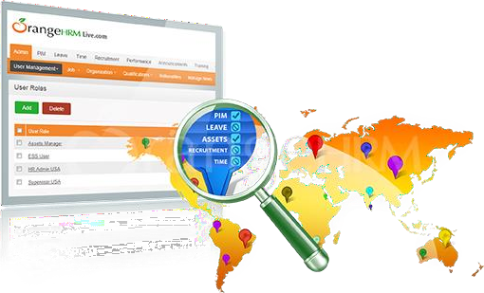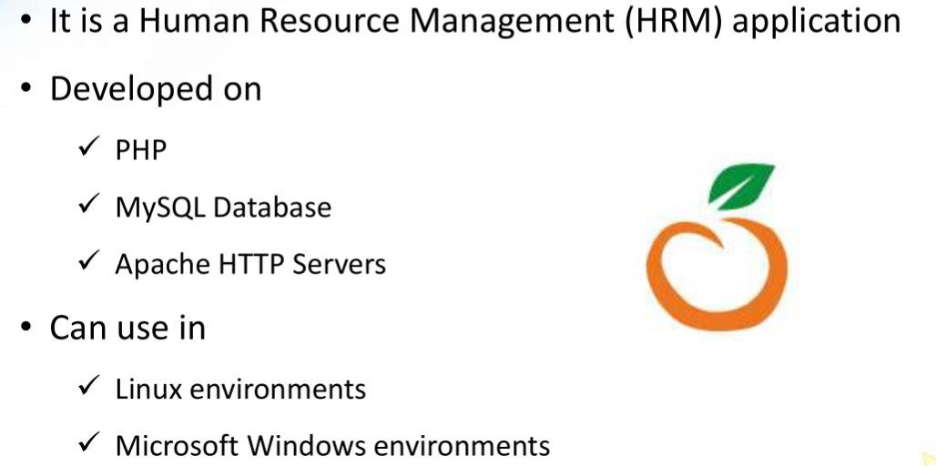

* Listing Employees/users
* Adding Employees
* Configure Leaves
* Time Sheets
* Recruitment
* Performance of Employees
* Leaves (Apply, Entitlements etc..)
* Filling Time sheets
* My Info - maintaining personal details
* Performance tracking

HRM Admin

Admin PIM

Leave

Time Recruitment Performance

ESS User

PIM

Leave Time

My Info Performance

